SUMMARY REPORT ON PRELIMINARY SURVEY FINDINGS ON “EDUCATIONAL PERFORMANCE IN CHOGSIA”
Introduction
The Chogsia Old Students Union (CHOGSU) has been working over the past years to contribute towards improving educational performance in the community. Efforts, to this end, included organizing community sensitization forums, Quiz competitions and Extra-Classes, among others. However, observed academic performance of students at the BECE does meet expectations, given general improvements in the learning environment, including the construction of a new JHS block and availability electricity in the community.
CHOGSU therefore requested the collaboration of Innovations for Sustainable Rural Development- ISRD, a Non-Profit Organization, to conduct a research to ascertain the causes of slow improvement in educational performance and make recommendations for actions to improve same. This report presents a summary of preliminary findings of a survey conducted on the subject, aforementioned. It must be noted that the report does not include qualitative data from key informant interviews and focus group discussions, thus, the findings herein are inconclusive.
Objectives of Study
The study sought to do the following;
- Establish the perception of educational stakeholders in the Chogsia Community about educational performance in the community.
- Ascertain the educational challenges in the community.
- Assess recommended actions for addressing the challenges confronting educational performance in the community.

Methodology
We used a mixed-method design for this study. This stems from the realization that educational performance is not limited to issues of quantification, but includes social perspectives and experiences within a cultural setting, which are not easily analysed quantitatively.
Thus, the study employed and survey, focus group discussions and key informant interviews. A sample size of 80 was used for the survey, four focus group discussions were conducted, while four key informant interviews were also conducted. The survey used questionnaire administered through the SurveyCTO electronic data platform.
Background of Respondents
Respondent Category
Respondents were grouped into four categories as shown in the table below.
RESPONDENT CATEGORY | NUMBER SAMPLED
Parent/Guardian | 29
PastStudent | 14
Student | 30
Teacher | 7
Grand Total | 80

Sex of Respondents
Category | Female | Male | Grand Total
Parent/Guardian | 14 | 15 | 29
PastStudent | 7 | 7 | 14
Student | 15 | 15 | 30
Teacher | 2 | 5 | 7
Grand Total | 38 | 42 | 80
Out of a total 80 respondents, 38 were females, while 42 were males, as shown below.

Educational Level of Respondents
Row Labels | JHS | None | Primary | Secondary | Tertiary | Vocational/Technical | Grand Total
Parents/Guardians | 2 | 22 | 5 |  |  |  | 29
Past Students |  |  |  | 7 | 6 | 1 | 14
Students | 20 |  | 10 |  |  |  | 30
Teachers |  |  |  |  | 7 |  | 7
Grand Total | 22 | 22 | 15 | 7 | 13 | 1 | 80

Findings
Perceptions about Performance at BECE
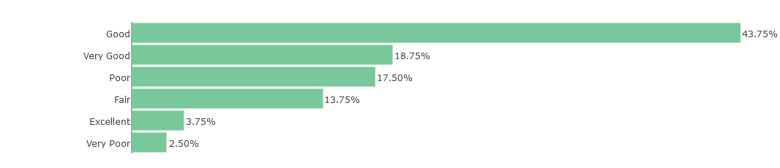
Reasons for poor performance
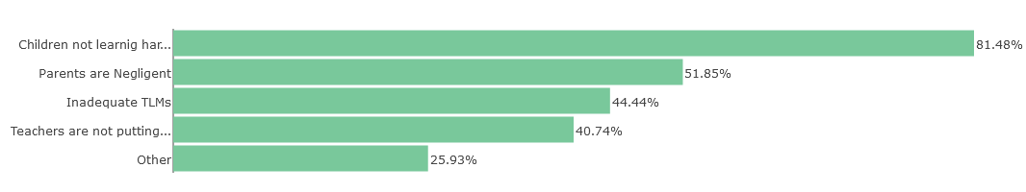
Other Reasons
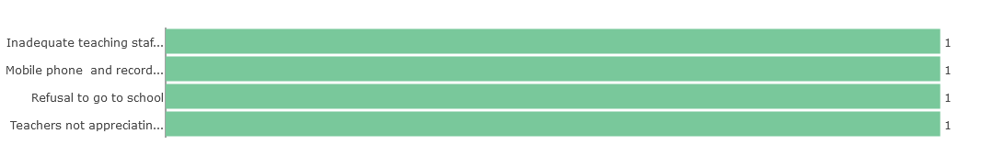
Gender Disparity in Performance
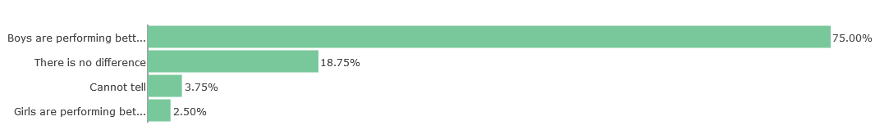
Reasons for Girls Performance
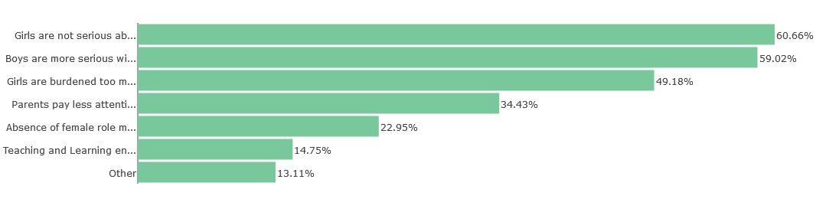
Challenges
Facilities
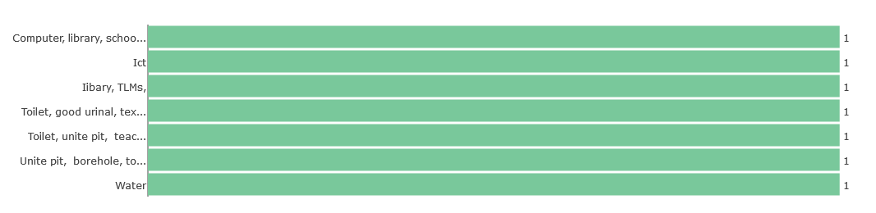
Parental Responsibility
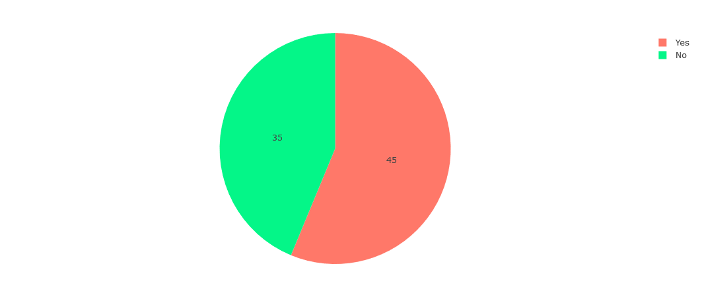
Students Responsibility
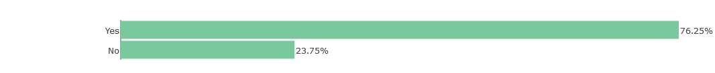
Teachers’ Responsibility
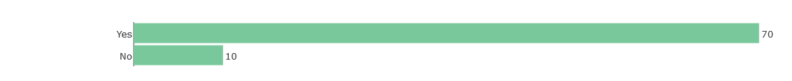
Who is to blame most for poor performance
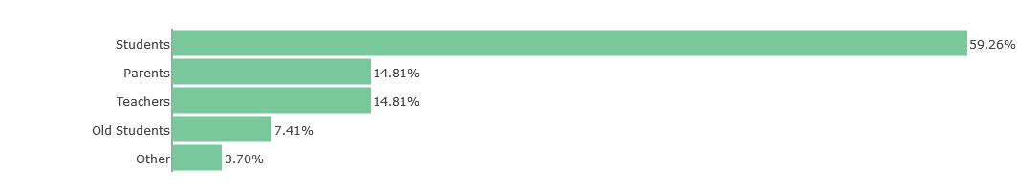
Recommended Solutions
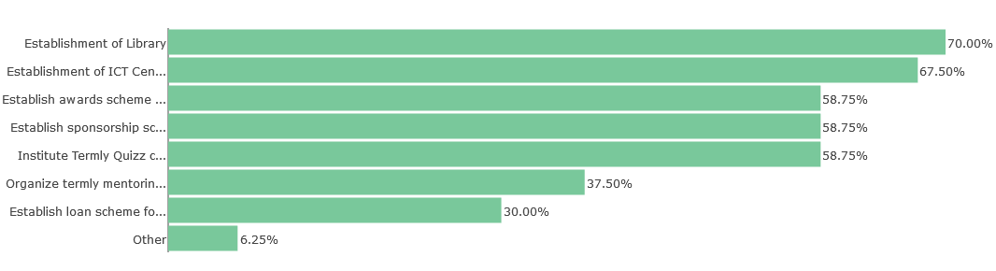
Recommended Solutions for Improving Girls’ Performance
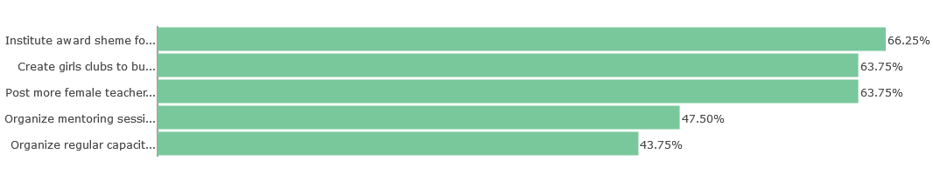

Conclusions
- More respondents thought that performance at the BECE over the past three years has been good, albeit, they think students don’t take their studies seriously enough.
- Inadequate TLMS, Computers and Water or absence of same constitute major challenges to performance.
- Boys are thought to be performing better than girls due to gender impediments, but also that girls are not taking their education as serious as boys.
- Establishment of Library and ICT Centre were most recommended solution for improving performance generally.
- Posting more female teachers to the schools, instituting an awards scheme for girls and creating girls clubs/mentoring were also most recommended actions to improve girls performance.

